Connecting **microevolutionary processes and macroevolutionary patterns** in damselflies and dragonflies

Mid-Term Review

John Waller

Lund, February 2nd 2016

# Summary

Here I argue that the results from phylogenetic comparative studies can inform the interpretation of microevolutionary and population biological studies, and vice versa. I discuss these questions with two interesting traits: body size and thermal performance. I show that the comparison of microevolutionary processes and macroevolutionary patterns can be useful and informative, because what appears to be unclear at one level can often be resolved at another level.

I present one manuscript and a summary of my PhD work. I have made several references to figures throughout the text, which will usually represent some major result from my thesis work. I give a brief introduction to the system of dragonflies and damselflies (odonates), which are insects with complex life cycles.

In the Methodology section, I describe two broad statistical modeling techniques: (1) measuring selection in the quantitative genetics framework (2) comparing phenotypes of separate species using phylogenetic comparative methods.

In Tools, I describe methods that were developed to aid this project and hopefully future work. First is the development of methods to compute selection gradients from mark-recapture models, since insects usually have low recapture probability. Second, I discuss the creation of the Odonate Phenotypic Database (opdb), an online resource for comparative studies in dragonflies and damselflies. In Application, I describe some details about how I built my large (1200 of 6000 taxa) odonate phylogenetic tree and past and ongoing field work with Calopoterygid damselflies in Skåne. Finally, I list planned and completed manuscripts.

Contents

Summary 1

Introduction 2

Connecting macro and micro evolution 2

Life History of Dragonflies and Damselflies 3

Phenotypic traits 3

Body Size Evolution 4

Thermal Performance 6

Methodology 7

Measuring Selection 7

The Comparative Method 8

Tools 9

Measuring Selection with imperfect detection and EasyMARK 9

Odonate Phenotypic Database (opdb) 10

Application 11

Building the phylogenetic tree 11

Measuring selection in the field 12

Measuring natural and sexual selection thermal plasticity in the field 12

Results and Progress 13

Planned and Completed Manuscripts 13

References 14

Figures 19

# Introduction

## Connecting macro and micro evolution

Population biology is useful for understanding ecology, behavior, and selection. However, there is often a question as to whether the results of any population-level study are applicable over longer macroevolutionary time scales (Arnold *et al.* 2001). Integrative studies are rarely done in practice comparing modern the two fields. However, such comparisons can be informative because what appears to be a paradox at one level can perhaps be resolved at another level. In the following mid-term report, I give several examples in my thesis work where macro and micro evolution can inform each other.

## Life history of dragonflies and damselflies

Dragonflies and damselflies (hereafter called odonates, referring to name of their order) are insects with complex life cycles, wherein growth and reproduction are divided roughly into four stages: 1. Egg 2. Larval 3. Immature 4. Adult. For simplicity it is helpful to informally call stages 1 and 2 the **larval stage** and stages 3 and 4 the **adult stage** (Stoks & Cordoba-Aguilar 2012). Events and conditions in the larval stage have been shown to have carry over effects and morphological and fitness consequences for the adult stage (Corbet 1999; Stoks & Cordoba-Aguilar 2012).

The aquatic larval stage (of several molts) is specialized for fast growth, and can last months and years in some species (Fig. 1). This is considerable longer than the adult stage, which usually lasts a few days or months (Fig. 2). In Fig. 3, I show that adult body size and time spent as a larva are positively related after controlling for phylogenetic non-independence, meaning that larger species tend to have longer aquatic phases (PGLS: est = 0.028, p = 0.023, N = 87). The largest dragonflies of the genus *Petalura*(200 mm body length) are purported to have larval stages lasting decades, uniquely living in burrows, which are probably predator defenses (Baird 2014).

Growing larva are subject to predation, parasites, and cannibalism. Larval activity increases mortality from predators (Mcpeek 2004), and time-constrained larvae increase their activity rates (Johansson & Rowe 1999). Larvae are also more active in turbid (cloudy) water than in clear water when fish predators present (van de Meutter *et al.* 2005). Gegarine parasites (gut parasites) and water mites have been shown to reduce mass and adult survival (Braune & Rolff 2001; Tsubaki & Hooper 2004). The longer larvae spends underwater, the higher the probability of infection or predation (Corbet 1999).

The winged adult stage is specialized for dispersal and reproduction. Males can have territorial or opportunistic mating systems (scramble competition). Territories can be important for plant substrates and flowing water, as egg survival usually increases in areas with higher flow rate (Siva-Jothy *et al.* 1995). Sexual selection and visual signaling are important in many dragonflies and damselflies(Tynkkynen *et al.* 2005; Svensson *et al.* 2007; Svensson & Waller 2013). Some species of the genus *Calopteryx* have dark wing pigment, which has been shown to be important for immunity function signaling (Siva-Jothy 2000).

Associations between wing pigmentation and male parasite resistance have been interpreted as supporting indicator models, or “good genes” models (Siva-Jothy 2000; Rantala *et al.* 2000). Other sexual selection studies indicate that wing pigmentation is important in male-male interference competition (Grether 1996; Tynkkynen *et al.* 2005), and it has also been demonstrated that pigmentation functions as a species recognition character and in sexual isolation, and shows a signature of latitudinal sorting, with the frequency of pigmented species higher in the temperate zone (Svensson & Waller 2013).

# Phenotypic traits

In my thesis so far, I have focused on two phenotypic characters: thermal performance (a physiological trait) and body size (a morphological trait). These two key phenotypic traits affect large aspects of an organism’s fitness, ecology, and evolution. Body size is particularly interesting as it tends to influence many other life history traits, yet is easily measured, and data are available on extant species and in the fossil record.

## Body size evolution

Oxygen and fossils

In the fossil record, there are odonate (Protodonata) specimens with wing lengths of 350 mm (700 mm wingspans), which are comparable to the size of an adult crow (Fig. 4)(Harrison *et al.* 2010). Higher atmospheric oxygen levels 300 mya are thought to be in part responsible for the large body sizes seen in dragonflies and other insects (Harrison *et al.* 2010). This idea is also supported by experimental work on fruit flies (*Drosophila*), which if raised in experimentally increased oxygen for multiple generations, evolve increased mean body size (Klok & Harrison 2009).

In Fig. 5, I plot the oxygen percentage in the atmosphere over the last 350 million years (GEOCARBSULF model)(Berner 2009). The peak atmospheric oxygen in this reconstruction corresponds well to the peak seen in giant insects 300 mya (Clapham & Karr 2012). An 10% increase in oxygen concentration is thought to be especially important in the energetically intensive process of flight (Harrison *et al.* 2010). Body size also appears to be decoupled from oxygen levels after that initial peak (Clapham & Karr 2012), although other oxygen-record reconstructions might show a different pattern (Harrison *et al.* 2010).

In Fig. 6, I show wing size fossil data (a surrogate for body size) from the Paleobiology Database (paleobiodb.org) (Clapham & Karr 2012). From this figure, it can be seen that small and intermediate lineages have coexisted with the large ones. Indeed the response to high oxygen conditions is not uniformly to increase, and some laboratory studies on insects have shown that they actually became smaller in higher oxygen levels (Harrison *et al.* 2010).

When oxygen is abundant it may allow insects to overcome some costly physiological constraints, and if growing larger has positive effects on survival, reproduction, or mating success, populations will evolve to become larger. No such evolutionary response would be expected, however, if there is no fitness benefits to being larger.

Lower atmospheric oxygen is not the only or even the most likely reason why maximum body size in odonates is presently smaller than in the past (Clapham & Karr 2012). Size-dependent predation by flying predators has been suggested as a constraint since 150 mya (Clapham & Karr 2012), and it has been shown – in two independent studies of an extant population of two Calopterygid species (*Calopteryx splendens* and *C. virgo*) that larger individuals (longer wings) are indeed more likely to be predated by birds (Svensson & Friberg 2007; Kuchta & Svensson 2014). Odonates may also have occupied niches that are now occupied by vertebrates (Harrison *et al.* 2010). Later on, I discuss the role of time and the rate of evolution as an additional reasons for the smaller body sizes seen in odonates today (see Methodology: The comparative method).

Microevolutionary selection studies

While there have been large increases and decreases in max body size (Fig. 6), observed changes in mean body size are fewer, suggesting that body size evolution in this group largely follows an un-biased random walk process, especially since the last mass extinction 65 mya (Fig. 6).

Despite this observed stasis, Sokolovska (Sokolovska *et al.* 2000) et al. (2000) performed a meta-analysis, showing that selection on body size (in odonates) in the adult stage (for both males and females) is largely positive (Fig. 7). I have updated this dataset with selection studies published between 2000-2015, and found a similar pattern of largely positive correlation coefficients (Fig 7).

There has been some concern that a correlation coefficient is not an ideal measure of selection (Thompson & Fincke 2002), since it cannot capture effect size or any curvature of the fitness function. In Fig. 7, I show using simulations the symmetrical distribution of correlation coefficients one would expect if selection were largely stabilizing. In contrast to this null expectation, I instead found a positive-skewed distribution in this dataset (Fig. 7), indicating that there is an overall trend of selection for larger body size in the adult stage, and this trend is seen across both sexes and for several different fitness components. From 2011-2014, I measured natural and sexual selection in a field population of *Calopteryx splendens* males (Fig. 8). Although there was pronounced year-to-year variation, sexual and natural selection on body size was positive. This positive effect was seen for both mating success and minimum lifespan. Finally, I have found no evidence for a convexly curved fitness function in this population, which would be expected if selection was primarily stabilizing (Fig 8). This does not mean that there is no optimal adult body size, but rather indicates that adults are being pushed off of their optimum by one or several process, such as countervailing selection pressures during other life stages. I argue that the most likely force pushing odonates off of their adult optimum is selection in the larval stage for reduced development time.

The role of latitude

Odonates are significantly smaller in the tropics than in temperate regions (even after controlling for phylogenetic non-independence) (Fig. 9) (PGLS: mean diff. = 1.5 mm, p = 0.014, se = 0.61). In tropical environments, where odonates presumably evolved, high temperatures might enable them to speed up development rates and have several generations per year (multivolitinism). Selection for large body size through female fecundity or male mating success is probably weaker than selection for fast development, as it is will be a higher premium to reproduce at a high rate, even if such a high reproductive rate comes at the cost of developing a larger body and hence delay emergence (Roff 1980). However, as odonates colonized northern latitudes and temperate environments, only one reproductive generation per year was possible (univolitinism). Selection to increase per-generation fecundity or mating success may have therefore favored larger body sizes and delayed development, sometimes up to several years.

In contrast, within a single species, body size tends to decrease (in the northern hemisphere) with increasing latitude, which may indicate that growth rates are similar along latitudes (Johansson 2003). Voltism shifts (shifts in the number of generations per year) can also be important for determining size across a latitudinal gradient. Some species show a U-shaped distribution: decreasing body size with latitude and then a sharp increase in body size after a voltism shift (De Block *et al.* 2008). Decreases in the length of the growing season and growth rate are possible explanations for smaller sizes seen at higher latitudes (De Block *et al.* 2008). A short growing season can be compensated for by increasing activity levels (De Block *et al.* 2008), but this likely exposes larvae to increased predation (Mcpeek 2004), so we expect to see smaller body size at mid latitudes.

Diversification and body

Body size distributions within taxonomic groups are often asymmetrical, with more smaller species than larger ones (Rainford et al 2016). Such a skewed distribution can be indicative size-dependent differences in diversification rate. In insects, Rainford *et al*. (2016) found little evidence for body size dependent diversification rates. In Fig. 10, I found some weak support for a negative effect of body size on speciation rate in odonates (linear model: est = 0.00, p = 0.8). Neither our study nor Rainford et al. (2016), however, were able to estimate extinction rates because of too many missing tip taxa (Nee et al. 1994), so body size may still affect diversification rates through extinction (i.e. since: diversification rate = extinction rate – speciation rate).

## Thermal performance

Climate change will likely increase mean temperatures, but it might also increase year-to-year fluctuations in temperature (Deutsch *et al.* 2008; Thomas *et al.* 2004). Especially in ectotherms, external temperature can affect many aspects of an organisms life, such flight, reproduction, survival, and development. Angilletta (2009) proposes that in terms of thermal performance organisms can be classified broadly as thermal specialist or thermal generalists.

Thermal performance can be quantified by measuring some phenotype (e.g. flying, running, mating rate), against different external temperatures. Thermal performance curves are usually not symmetrical, with performance slowly rising to an optimum and then quickly declining (Levins 1969; Huey & Kingsolver 1993). Generally the most interesting phenotypes would be those that have some fitness consequences, and individuals within populations are expected to show variation in their performance curves in terms of both thermal breathes and optima. For example, individuals with different optima would have increased fitness at one temperature but reduced fitness at another temperature (Levins 1969; Palaima 2007). These types of tradeoffs are likely seen because of low-level enzymatic constraints, but also higher-level phenotypes like body size are similarly unlikely to be optimal for a broad range of temperatures (Angilletta 2009). So-called “jacks of all temperatures” – successful thermal generalists are thought to be rare (Huey & Hertz 1984; Angilletta 2009).

Natural selection may not only affect performance optima, but it may also act on the breath of the performance curve, and lead to a type of phenotypic canalization (a type of overfitting) to an rarely fluctuating environment. Tropical species in particular are predicted to have narrow performance curves, and are therefore expected to react poorly in fluctuating environments (Gibert *et al.* 2001; (Stillman 2003; Kimura 2004).

In my ongoing research on thermal performance, I have two related projects: one on damselflies in the field and one on fruit flies (Drosophila melanogaster) in the laboratory. Thermal performance curves are difficult to measure in the field, so I have opted to measure reproductive performance under different temperatures in fruit flies instead (although I have plans to measure flight performance under different temperature regimes in damselflies). Using isogenic fruitflies from the Drosophila Genome Reference Panel (DGRP) (Mackay *et al.* 2012), I aim to investigate if different genotypes have different genetically determined thermal optima in terms of male mating rates. How well an insect can buffer itself against external temperature or, conversely, how well it responds (heats up) to external temperature, will likely have large fitness consequences.

In damselflies, I predict that males that are able to heat up faster might have higher mating success than those individuals with lower heating rates, since, for example, maximum powered flight is highly dependent on muscle temperature (May 1995). Alternatively, variability in the environment could instead favor individuals that are able to withstand a period of cooling (such as night or clouds ), i.e. increased canalization (Lande 2009). To study these questions, I have quantified individual variation in *thermal reaction norms*, as defined by Angiletta (2009), and related this phenotypic variation to fitness in terms of survival and male mating success. Finally, *Calopteryx splendens* males might utilize their melanin-composed wing patch as a solar absorber as well as a sexual signal (i.e. this trait could have multiple functions in both sexual and natural selection) (Svensson & Waller 2013).

# Methodology

## Measuring selection

If we ignore the curvature of the fitness function, we can make simple predictions about expected evolutionary changes in population mean phenotypes using the following equation, as developed from quantitative genetics (Lynch & Walsh 1998)

∆**ẑ** = **G**β (1)

Where, ∆**ẑ** denotes a vector of changes in phenotypic means of the population, β denotes a directional selection gradient vector, **G** denotes the genetic variance-covariance matrix (Lande 1979). Depending on the structure of the G matrix, and making some assumptions about the multi-variate normality of the measured traits, we can use this information to predict the direction and magnitude of evolutionary change in natural populations (Lande & Arnold 1983).

It is important to emphasize that measuring selection (β) is different from measuring the reaction to selection (∆**ẑ**). If one knows ∆**ẑ** and **G** for a set of phenotypes, it is possible to solve for β, but such information is rarely available in natural populations . Lande and Arnold (1983), pointed out that fitness could be split into different components, such as survival, viability selection (survival to sexual maturity), mating success (the number of mates), or fecundity (the number of eggs). These components of fitness can then be used to quantify selection on the given set of phenotypes. The product of these different components of fitness can be combined to produce selection on total fitness.

Such a fitness function could be written as a simple linear model:

w = α + βz + ½γz2 (2)

Where w is relative fitness, α is an intercept term, β is a linear selection gradient, z is a standardized trait vector and γ provides information about any curvature in the fitness surface (e. g. disruptive or stabilizing selection). The practical implementation of Lande and Arnold's method involves simply fitting a linear model with standardized response (survival ,mating success, fecundity) and explanatory (trait) variables values with quadratic terms (multiplied by two) (Stinchcombe *et al.* 2008). These straightforward statistical methods have stimulated evolutionary biologists to measure literally thousands selection coefficients using commonly available statistical software (Kingsolver *et al.* 2001).

It is important to remember that genetic covariances (**G**) between traits can change what the response to selection will ultimately be in the next generation. Additionally, un-measured components of total fitness or un-measured traits can change the evolutionary response to selection (Grafen 1989; Hadfield 2008). For example, some individuals might die before a trait is measured or expressed (the so-called “invisible fraction”) (Grafen 1989). These types of issues might be especially common in animals with complex lifecycles, such as odonates, where selection in the adult life stage is easier to measure than selection in the aquatic larval stage.

## The comparative method

Often there are questions that cannot be answered by experimentation: When did a trait evolve? What is the rate of evolution? Are these two traits convergent? Why does this group have more species than another group? Phylogenetic comparative methods offer ways to address these questions and others (Pagel & Harvey 1988; Pagel 1999; Zsolt 2014).

Generally (although not exclusively), comparative methods use trait data from extant taxa and a phylogenetic tree to perform inferences or detect some pattern (Hansen & Martins 1996). Most comparative methods benefit from having a time-dated phylogenetic tree, which can usually be constructed from aligned genes and fossils after making some assumptions about the rate of mutation. Then typically some hierarchal clustering method is performed to produce a matrix of relatedness (Felsenstein 1984; Saitou & Nei 1987; Yang 1994). This relatedness and the divergence times are then in most cases incorporated into a covariance matrix of multi-variant normal distribution, and some inference is performed (Grafen 1989; Felsenstein 1997; Hansen & Martins 1996).

The inferred covariance matrix need not be perfect (i.e. it does not need to have a topology that exactly reflects evolutionary events) for non-independence to be adequately accounted for. Lacking a phylogeny, a taxonomy-level-based (family, genus, species) covariance matrix will usually suffice (Evans *et al.* 2012; Soul & Friedman 2015), although it is of course better to have a phylogeny that is as “true” as possible, although it should be emphasized that a phylogeny is always a hypothesis of the true underlying evolutionary relationships (Donoghue & Ackerly 1996). Uncertainty about divergence dates and topology can be incorporated if one takes a probabilistic and pragmatic perspective to tree building (Huelsenbeck *et al.* 2001; Pagel *et al.* 2004). While taxonomists strive to construct a fully dichotomous and trees with nodes that have low uncertainty, in some circumstances, a comparative biologist can be more pragmatic about uncertainty, since the exact relationship between taxa is not usually the main objective (Martins & Housworth 2002).

Modern probabilistic approaches to tree building can produce a posterior sample of trees, which can capture the uncertainty present in the topology and divergence dates (Drummond & Rambaut 2007). This sample of trees can then be used in any downstream comparative analysis. This will of course increase the uncertainty of any estimated parameters, but this uncertainty will reflect reality and might be acceptable. This pragmatic strategy allows one to make inferences and test models of evolution without having to wait for the “perfect phylogenetic tree.” It is this type of approach that I have employed in this thesis.

For continuous characters, a simple model of evolution is a random walk process (Hansen 1997). A random walk can be modeled as draws from a normal distribution at each time step, which are then added (or subtracted) from the previous time step. This process can be run several times, with each path taken representing a lineage drifting randomly though character space (Fig. 11). How quickly a trait evolves will depend on the rate of evolution, which is the variance of the normal distribution described above. The end result should produce a group of extant lineages spread with an expected value of the variance equal to the time*rate (Fig. 11).

This Brownian motion model of evolution assumes that there are no constraints on upper or lower bounds of this process. Constraints can however be measured by adding an extra term to our model, which measures a pullback force as traits drift further away from the mean. This type of model is called Ornstein-Uhlenbeck (OU) model (Hansen 1997; Butler & King 2004).

For odonates, aside from the trivial constraint that body size cannot be negative, several constraints have been proposed on the upper limit of body size. About 300 mya and 150 mya odonates seem to have reached some local maxima in body size, according to the fossil record (Fig. 6). Since that time odonates have become smaller. This has led to the suggestion that birds are constraining maximum body size in this group, since they evolved around 150 mya. Another suggestion is that atmospheric oxygen levels are the limiting force (Harrison *et al.* 2010), since atmospheric oxygen levels were much higher about 300 mya (Fig. 5).

OU models are not able to assign causation to the constraints they measure, but they can tease out the rate of evolution (rate of change in the trait). In Fig. 12, I show that odonates in the modern age (the last 65 my since the last major extinction event), likely have not had enough time to reach the sizes observed in the fossil record 300 mya, but they nevertheless and with current selective constraints (caused by oxygen levels, birds, or some other ecological agent), they are likely to remain small until the constraints on their body size are relaxed.

# Tools

During the course of this project it was obvious several tools were missing or needed improvement. First, I needed a large amount of body size data and other phenotypic data, which was spread out in the literature. Second, I needed to measure survival selection in a small insect with low recapture probability. In the next section, I discuss how the I addressed this second problem.

## Measuring Selection with imperfect detection and EasyMARK

The quantification of survival selection in the field has a long history in evolutionary biology. A considerable milestone in this field was the highly influential publication by [Russel Lande and Steve Arnold](http://people.oregonstate.edu/~arnoldst/pdf_files/Lande%20&%20Arnold%201983.pdf) in the early nineteen eighties (Lande & Arnold 1983). The practical implementation of Lande and Arnold's method involved simply fitting a linear model with standardized response (survival) and explanatory (trait) variables values with quadratic terms (multiplied by two) (Stinchcombe *et al.* 2008). This straightforward method has allowed evolutionary biologists to measure selection coefficients using commonly available statistical software, and these estimates could be used directly within a quantitative genetic framework.

There are several drawbacks to implementing the Lande-Arnold method as described above, one of which is the inability to account for when marked individuals are not seen on every catching occasion. With very few exceptions, evolutionary ecologists tend to ignore imperfect detection and assume that the linear-regression based methods described above are robust to any biases created by imperfect detection (Clobert 1995; Gimenez *et al.* 2008).   
  
Sophisticated methods have existed for some time however that take recapture probability into account and attempt to correct for it when present (Lebreton *et al.* 1992). These more complex statistical methods have not become widely used among evolutionary ecologists, likely because the estimates produced by software such as [MARK](http://warnercnr.colostate.edu/~gwhite/mark/mark.htm) do not return output which is directly comparable with classical standardized selection gradients (White & Burnham 1999). Additionally, it is simply harder to implement a complicated mark-recapture model than linear regression with some standardization.   
  
So even though imperfect detection has been recognized as a problem, the severity of this problem has never been quantified using systematic simulations. And until now no method has been developed to transform estimates produced by mark-recapture models into estimates of selection that can be used within quantitative genetics.   
  
This raises some important questions: Should past studies be reanalyzed? How low does recapture probability have to be before it becomes a problem? In which direction would imperfect detection effect the estimates of selection – if any? How good are the currently available statistical techniques at correcting such errors? In my recent paper published in *Methods in Ecology and Evolution* (attached), we show how robust naive linear-regression based are in relation to less than perfect detection and trait-biased detection rates.   
  
My main finding is that all methods lose statistical power with decreasing recapture probability, and trait-dependent recapture probability becomes an issue mainly when recapture probabilities are trait-dependent and low (Fig. 13). Note that we use “trait dependence” in the broad sense, such as when recapture probabilities are heterogeneous is some way. Such heterogeneous recapture probabilities are not restricted to quantitative phenotypic traits, but could also include time or discrete phenotypic categories, such as sex effects. Nevertheless, it is often hard to tell a priori if trait-dependence or low recapture probability is an issue within a dataset, making the use of mark-recapture methods the safest choice even in scenarios when it may only have low impact on the conclusions. We produced R scripts and a new R-package [EasyMARK](https://cran.r-project.org/web/packages/EasyMARK/index.html) along with the paper to facilitate research in this area. Finally, we provide R code of a method developed by [Michael Morrissey](http://biology.st-andrews.ac.uk/contact/staffProfile.aspx?sunid=mbm5) (Morrissey) which allows estimates produced by mark-recapture models to be transformed into selection gradients.

## Odonate Phenotypic Database (opdb)

Genetic information, while still costly to sequence, is fairly easy to store and catalog. Phenotypic data is easier to gather but substantially harder to store and catalog (Houle *et al.* 2010). Some morphological traits are, however, amenable to storage in a database. Body size, for example, and other simple morphological traits are more likely to be comparable and measured in many representatives in a given group.

While the genetic code is a digital code common to all life, any attempt at a phenotypic database is more likely to succeed when it is group-specific. This means that any database needs to be tailored to specific aspects of the given group. This fact has inspired the creation of the Odonate Phenotypic Database (opdb). This database currently contains information on basic morphology, habitat, behavior, occurrences, and selection for a large fraction of the approximately 6000 odonate species.

Interestingly, it is often the case that we have more genetic data publicly available for a given odonate species than simple phenotypic data, such as body size (Fig. 14). This paradox must at least in part be due to the ease by which genetic data can be stored and the web structures that exists to store this data, such as GeneBank. For these reasons, I plan to migrate our database to the web, and eventually make it publicly available.

Finally, simply because genes exist on Genebank does not mean that they are cataloged and annotated in a way can easily be converted into a time-dated phylogenetic tree. By cataloging and curating both phylogenetic and phenotypic data our Odonate Phenotypic Database ultimate aim is to become a resource for comparative studies within this group.

# Application

## Building the phylogenetic tree

Species names were downloaded from the World Odonata List at www.pugetsound.com (Schorr & Paulson 2015). Using this list, we queried GeneBank for each species and downloaded all of the hit data. All the data from the hits were then automatically downloaded using the R package “seqinr” (Charif & Lobry 2007). Annotations were then processed and cleaned to determine the downloaded gene. The following genes were used in the construction of the tree: cytochrome oxidase I, 16S ribosomal RNA , internal transcribed spacer 1, internal transcribed spacer 2, 5.8S ribosomal RNA, 28S ribosomal RNA, and 18S ribosomal RNA (Fig. 15). Cleaned gene products were then aligned using the R package “muscle” (Edgar 2004) and in parallel using the R package “foreach” (Weston 2014). The alignments were then processed using gblocks, which eliminates poorly aligned positions (Castersana 2000). This was done using the gblocks function in the R package “phyloch” (Heibl 2013).

Tree construction was done using BEAST v1.8.1 (Drummond 2007). Dated fossils were downloaded from the Paleobiology Database (fossilworks.org)(Alroy 2014) and assigned to an extant genus or family (Fig. 16). Beast xml files were generated using modified version of the rbeauti function in the R package “phyloch” (Heibl 2013). The oldest dated fossils from each genus or family were then used as a minimum age for that group. Priors for divergence dates for genera were set with lognormal priors with sd = 1. Taxonomy was used as a backbone tree, meaning that during the tree building phase species were only allowed to move within their named genus (or to genera within their currently accepted families). BEAST was run for generations 10e6 burn-in was 10e4, and sampling frequency was 10e3. A consensus tree was then computed from 1000 posterior trees (Fig. 14).

## Measuring selection in the field

Field Site

Selection measurements come from a well-studied damselfly population of the banded demoiselle (*Calopteryx* *splendens*) in the southern part of the Swedish province Skåne, near Sövdemölla gård at Sövdesjön. Data was collected each summer (June and July) from for five years (2011, 2012, 2013, 2014, 2015). Our field site was located from 2012-2015 in the Swedish province Skåne, near Sövdemölla gård at Sövdesjön. Our field site was for 2011 was Klingavälsån Skåne. These populations are located within the same river system (Klingavälsån) as previous work that has been performed on this species further upstream (Svensson *et al.* 2006) (Svensson *et al.* 2007) (Wellenreuther *et al.* 2010).

Field studies of selection on morphology and thermal physiology

Male and females of the banded demoiselle(*Calopteryx splendens*) and the beautiful demoiselle (C. virgo) were captured at a sympatric site (Klingavälsån at Sövdemölla) (Fig. 17) and processed in the field. Individual damselflies were measured by placing their wings flat against two layers of transparency paper. A digital photo or scan was then taken with a known scale and the body traits were measured in ImageJ (Schneider *et al.* 2012). Individuals were marked with a unique 3 color code on the last 3 segments of the abdomen. This marking was used to identify males and measure survival. Apart from catching single individuals, I also caught all copulating pairs I could obtain in the field to estimate sexual selection through mating success.

## Measuring natural and sexual selection thermal plasticity in the field

At the same field site described above (in 2013, 2014, 2015), we also took measures of heating rate (Fig. 18), which is a measure of thermal performance and from which thermal reaction norms (Angiletta 2009) and associated parameters (slopes and intercepts) can be quantified. Males and females from two species (*Calopteryx splendens* and *virgo*) were captured and processed (individually marked and and their morphological traits measured) in mixed batches of 6 individuals. They were then kept inside a cooler at approximately 5o C for 3 minutes. The individuals were then placed inside small open cups in the ambient temperature environment for 3 minutes and allowed move freely. We used a thermal imaging camera (Svensson & Waller 2013) to take images of the damselflies every 10 seconds for 3 minutes to record changes in body temperature as they heated up in the field. Thermal images were later processed, and mean thorax temperature for each image was used as a measure of body size, because the temperature of the thorax is presumably most important for flight performance and hence survival and mating success in the field.

# Results and progress

## Planned and completed manuscripts

1. John Waller and Erik Svensson**. The measurement of selection when detection is imperfect: How good are naïve methods?** (2015). Methods in Ecology and Evolution. *†
2. John Waller, Erik Svensson. **Body Size Evolution in Odonates**.
3. John Waller, Erik Svensson, Jessica Abbott. **Genotype-by-environment interaction for temperature-dependent sexual selection through mating success in fruitflies (*Drosophila melanogaster*).**
4. John Waller and Erik Svensson. **Natural and sexual selection on thermal plasticity and canalization in insects.**
5. John Waller and Erik Svensson. **Body size and diversification in Odonates.**
6. John Waller and Erik Svensson. **Multivariate sexual selection in two sympatric odonate species.**
7. John Waller, Beatriz Willink, and Erik Svensson. **Odonate Phenotypic Database.**

* attached to this document, † published

# References

Angilletta, M. J. 2009. Thermal adaptation: a theoretical and empirical synthesis. Oxford University Press.

Alroy, J. 2014. Fossilworks. Gateway to the paleobiology database.

Arnold, S. J., M. E. Pfrender, and A. G. Jones. 2001. The adaptive landscape as a conceptual bridge between micro- and macroevolution. Genetica **112**:9-32.

Baird, I. R. C. 2014. Larval burrow morphology and groundwater dependence in a mire-dwelling dragonfly, Petalura gigantea (Odonata: Petaluridae). International Journal of Odonatology **17**:101-121.

Berner, R. A. 2009. Phanerozoic Atmospheric Oxygen: New Results Using the Geocarbsulf Model. American Journal of Science **309**:603-606.

Braune, P., and J. Rolff. 2001. Parasitism and survival in a damselfly: does host sex matter? Proceedings of the Royal Society B-Biological Sciences **268**:1133-1137.

Butler, M. A., and A. A. King. 2004. Phylogenetic comparative analysis: A modeling approach for adaptive evolution. American Naturalist **164**:683-695.

Castresana, J. 2000. Selection of conserved blocks from multiple alignments for their use in phylogenetic analysis. Molecular biology and evolution 17.4: 540-552.

Charif, D. and J. Lobry. 2007. SeqinR 1.0-2: a contributed package to the R project for statistical computing devoted to biological sequences retrieval and analysis. Structural approaches to sequence evolution. Springer Berlin Heidelberg: 207-232.

Clapham, M. E., and J. A. Karr. 2012. Environmental and biotic controls on the evolutionary history of insect body size. Proceedings of the National Academy of Sciences of the United States of America **109**:10927-10930.

Clobert, J. 1995. Capture-recapture and evolutionary ecology: A difficult wedding? Journal of Applied Statistics **22**:989-1008.

Corbet, P 1999. Dragonflies: behaviour and ecology of Odonata. Harley Books.

De Block, M., S. Slos, F. Johansson, and R. Stoks. 2008. Integrating life history and physiology to understand latitudinal size variation in a damselfly. Ecography **31**:115-123.

Deutsch, C. A., J. J. Tewksbury, R. B. Huey, K. S. Sheldon, C. K. Ghalambor, D. C. Haak, and P. R. Martin. 2008. Impacts of climate warming on terrestrial ectotherms across latitude. Proceedings of the National Academy of Sciences of the United States of America **105**:6668-6672.

Donoghue, M. J., and D. D. Ackerly. 1996. Phylogenetic uncertainties and sensitivity analyses in comparative biology. Philosophical Transactions of the Royal Society B-Biological Sciences **351**:1241-1249.

Drummond, A. J., and A. Rambaut. 2007. BEAST: Bayesian evolutionary analysis by sampling trees. Bmc Evolutionary Biology **7**.

Edgar. R.C. 2004. MUSCLE: multiple sequence alignment with high accuracy and high throughput Nucleic Acids Res. 32:1792-1797.

Evans, A. R., D. Jones, A. G. Boyer, J. H. Brown, D. P. Costa, S. K. M. Ernest, E. M. G. Fitzgerald, M. Fortelius, J. L. Gittleman, M. J. Hamilton, L. E. Harding, K. Lintulaakso, S. K. Lyons, J. G. Okie, J. J. Saarinen, R. M. Sibly, F. A. Smith, P. R. Stephens, J. M. Theodor, and M. D. Uhen. 2012. The maximum rate of mammal evolution. Proceedings of the National Academy of Sciences of the United States of America **109**:4187-4190.

Felsenstein, J. 1984. Distance Methods for Inferring Phylogenies - A Justification. Evolution **38**:16-24.

Felsenstein, J. 1997. An alternating least squares approach to inferring phylogenies from pairwise distances. Systematic Biology **46**:101-111.

Gibert, P., B. Moreteau, G. Petavy, D. Karan, and J. R. David. 2001. Chill-coma tolerance, a major climatic adaptation among Drosophila species. Evolution **55**:1063-1068.

Gimenez, O., A. Viallefont, A. Charmantier, R. Pradel, E. Cam, C. R. Brown, M. D. Anderson, M. B. Brown, R. Covas, and J. M. Gaillard. 2008. The risk of flawed inference in evolutionary studies when detectability is less than one. American Naturalist **172**:441-448.

Grafen, A. 1989. The Phylogenetic Regression. Philosophical Transactions of the Royal Society of London Series B-Biological Sciences **326**:119-157.

Grether, G. F. 1996. Intrasexual competition alone favors a sexually dimorphic ornament in the rubyspot damselfly Hetaerina americana. Evolution **50**:1949-1957.

Hadfield, J. D. 2008. Estimating evolutionary parameters when viability selection is operating. Proceedings of the Royal Society B-Biological Sciences **275**:723-734.

Hansen, T. F. 1997. Stabilizing selection and the comparative analysis of adaptation. Evolution **51**:1341-1351.

Hansen, T. F., and E. P. Martins. 1996. Translating between microevolutionary process and macroevolutionary patterns: The correlation structure of interspecific data. Evolution **50**:1404-1417.

Harrison, J. F., A. Kaiser, and J. M. VandenBrooks. 2010. Atmospheric oxygen level and the evolution of insect body size. Proceedings of the Royal Society B-Biological Sciences **277**:1937-1946.

Heibl, C. 2013. PHYLOCH: R language tree plotting tools and interfaces to diverse phylogenetic software packages.

Houle, D., D. R. Govindaraju, and S. Omholt. 2010. Phenomics: the next challenge. Nature Reviews Genetics **11**:855-866.

Huelsenbeck, J. P., F. Ronquist, R. Nielsen, and J. P. Bollback. 2001. Evolution - Bayesian inference of phylogeny and its impact on evolutionary biology. Science **294**:2310-2314.

Huey, R. B., and P. E. Hertz. 1984. Is A Jack-Of-All-Temperatures A Master of None. Evolution **38**:441-444.

Huey, R. B., and J. G. Kingsolver. 1993. Evolution of Resistance to High-Temperature in Ectotherms. American Naturalist **142**:S21-S46.

Johansson, F. 2003. Latitudinal shifts in body size of Enallagma cyathigerum (Odonata). Journal of Biogeography **30**:29-34.

Johansson, F., and L. Rowe. 1999. Life history and behavioral responses to time constraints in a damselfly. Ecology **80**:1242-1252.

Kimura, M. T. 2004. Cold and heat tolerance of drosophilid flies with reference to their latitudinal distributions. Oecologia **140**:442-449.

Kingsolver, J. G., H. E. Hoekstra, J. M. Hoekstra, D. Berrigan, S. N. Vignieri, C. E. Hill, A. Hoang, P. Gibert, and P. Beerli. 2001. The strength of phenotypic selection in natural populations. American Naturalist **157**:245-261.

Klok, C. J., and J. F. Harrison. 2009. Atmospheric Hypoxia Limits Selection for Large Body Size in Insects. Plos One **4**.

Kuchta, S. R., and E. I. Svensson. 2014. Predator-Mediated Natural Selection on the Wings of the Damselfly Calopteryx splendens: Differences in Selection among Trait Types. American Naturalist **184**:91-109.

Lande, R. 1979. Quantitative Genetic-Analysis of Multivariate Evolution, Applied to Brain - Body Size Allometry. Evolution **33**:402-416.

Lande, R. 2009. Adaptation to an extraordinary environment by evolution of phenotypic plasticity and genetic assimilation. Journal of Evolutionary Biology **22**:1435-1446.

Lande, R., and S. J. Arnold. 1983. The Measurement of Selection on Correlated Characters. Evolution **37**:1210-1226.

Lebreton, J. D., K. P. Burnham, J. Clobert, and D. R. Anderson. 1992. Modeling Survival and Testing Biological Hypotheses Using Marked Animals - A Unified Approach with Case-Studies. Ecological Monographs **62**:67-118.

Levins, R. 1969. Thermal Acclimation and Heat Resistance in Drosophila Species. American Naturalist **103**:483-&.

Lynch, M. and B. Walsh. 1998. Genetics and analysis of quantitative traits. Vol. 1. Sunderland, MA: Sinauer.

Mackay, T. F. C., S. Richards, E. A. Stone, A. Barbadilla, J. F. Ayroles, D. H. Zhu, S. Casillas, Y. Han, M. M. Magwire, J. M. Cridland, M. F. Richardson, R. R. H. Anholt, M. Barron, C. Bess, K. P. Blankenburg, M. A. Carbone, D. Castellano, L. Chaboub, L. Duncan, Z. Harris, M. Javaid, J. C. Jayaseelan, S. N. Jhangiani, K. W. Jordan, F. Lara, F. Lawrence, S. L. Lee, P. Librado, R. S. Linheiro, R. F. Lyman, A. J. Mackey, M. Munidasa, D. M. Muzny, L. Nazareth, I. Newsham, L. Perales, L. L. Pu, C. Qu, M. Ramia, J. G. Reid, S. M. Rollmann, J. Rozas, N. Saada, L. Turlapati, K. C. Worley, Y. Q. Wu, A. Yamamoto, Y. M. Zhu, C. M. Bergman, K. R. Thornton, D. Mittelman, and R. A. Gibbs. 2012. The Drosophila melanogaster Genetic Reference Panel. Nature **482**:173-178.

Martins, E. P., and E. A. Housworth. 2002. Phylogeny shape and the phylogenetic comparative method. Systematic Biology **51**:873-880.

Maurer, B. A., J. H. Brown, and R. D. Rusler. 1992. The Micro and Macro in Body Size Evolution. Evolution **46**:939-953.

May, M. L. 1995. Dependence of Flight Behavior and Heat-Production on Air-Temperature in the Green Darner Dragonfly Anax-Junius (Odonata, Aeshnidae). Journal of Experimental Biology **198**:2385-2392.

Mcpeek, M. A. 2004. The growth/predation risk trade-off: So what is the mechanism? American Naturalist **163**:E88-E111.

Pagel, M. 1999. Inferring the historical patterns of biological evolution. Nature **401**:877-884.

Pagel, M., A. Meade, and D. Barker. 2004. Bayesian estimation of ancestral character states on phylogenies. Systematic Biology **53**:673-684.

Pagel, M. D., and P. H. Harvey. 1988. Recent Developments in the Analysis of Comparative Data. Quarterly Review of Biology **63**:413-440.

Palaima, A. 2007. The fitness cost of generalization: present limitations and future possible solutions. Biological Journal of the Linnean Society **90**:583-590.

Rantala, M. J., J. Koskimaki, J. Taskinen, K. Tynkkynen, and J. Suhonen. 2000. Immunocompetence, developmental stability and wingspot size in the damselfly Calopteryx splendens L. Proceedings of the Royal Society B-Biological Sciences **267**:2453-2457.

Roff, D. 1980. Optimizing Development Time in A Seasonal Environment - the Ups and Downs of Clinal Variation. Oecologia **45**:202-208.

Saitou, N., and M. Nei. 1987. The Neighbor-Joining Method - A New Method for Reconstructing Phylogenetic Trees. Molecular Biology and Evolution **4**:406-425.

Schorr, M., and D. Paulson. 2015 World Odonata List.

Schneider, C. A., W. S. Rasband, and K. W. Eliceiri. 2012. NIH Image to ImageJ: 25 years of image analysis. Nature Methods **9**:671-675.

Siva-Jothy, M. T., Gibbons, D. W., and D. Pain. 1995. Female oviposition-site preference and egg hatching success in the damselfly Calopteryx splendens xanthostoma. Behavioral Ecology and Sociobiology **37.1**: 39-44.

Siva-Jothy, M. T. 2000. A mechanistic link between parasite resistance and expression of a sexually selected trait in a damselfly. Proceedings of the Royal Society B-Biological Sciences **267**:2523-2527.

Sokolovska, N., L. Rowe, and F. Johansson. 2000. Fitness and body size in mature odonates. Ecological Entomology **25**:239-248.

Soul, L. C., and M. Friedman. 2015. Taxonomy and Phylogeny Can Yield Comparable Results in Comparative Paleontological Analyses. Systematic Biology **64**:608-620.

Stillman, J. H. 2003. Acclimation capacity underlies susceptibility to climate change. Science **301**:65.

Stinchcombe, J. R., A. F. Agrawal, P. A. Hohenlohe, S. J. Arnold, and M. W. Blows. 2008. Estimating nonlinear selection gradients using quadratic regression coefficients: Double or nothing ? Evolution **62**:2435-2440.

Stoks, R., and A. Cordoba-Aguilar. 2012. Evolutionary Ecology of Odonata: A Complex Life Cycle Perspective. Annual Review of Entomology, Vol 57 **57**:249-265.

Svensson, E. I., F. Eroukhmanoff, and M. Friberg. 2006. Effects of natural and sexual selection on adaptive population divergence and premating isolation in a damselfly. Evolution **60**:1242-1253.

Svensson, E. I., and M. Friberg. 2007. Selective predation on wing morphology in sympatric damselflies. American Naturalist **170**:101-112.

Svensson, E. I., K. Karlsson, M. Friberg, and F. Eroukhmanoff. 2007. Gender differences in species recognition and the evolution of asymmetric sexual isolation. Current Biology **17**:1943-1947.

Svensson, E. I., and J. T. Waller. 2013. Ecology and Sexual Selection: Evolution of Wing Pigmentation in Calopterygid Damselflies in Relation to Latitude, Sexual Dimorphism, and Speciation. American Naturalist **182**:E174-E195.

Thomas, C. D., A. Cameron, R. E. Green, M. Bakkenes, L. J. Beaumont, Y. C. Collingham, B. F. N. Erasmus, M. F. de Siqueira, A. Grainger, L. Hannah, L. Hughes, B. Huntley, A. S. van Jaarsveld, G. F. Midgley, L. Miles, M. A. Ortega-Huerta, A. T. Peterson, O. L. Phillips, and S. E. Williams. 2004. Extinction risk from climate change. Nature **427**:145-148.

Thompson, D. J., and O. M. Fincke. 2002. Body size and fitness in Odonata, stabilising selection and a meta-analysis too far? Ecological Entomology **27**:378-384.

Tsubaki, Y., and R. E. Hooper. 2004. Effects of eugregarine parasites on adult longevity in the polymorphic damselfly Mnais costalis Selys. Ecological Entomology **29**:361-366.

Tynkkynen, K., J. S. Kotiaho, M. Luojumaki, and J. Suhonen. 2005. Interspecific aggression causes negative selection on sexual characters. Evolution **59**:1838-1843.

van de Meutter, F., R. Stoks, and L. De Meester. 2005. The effect of turbidity state and microhabitat on macroinvertebrate assemblages: a pilot study of six shallow lakes. Hydrobiologia **542**:379-390.

Wellenreuther, M., E. Vercken, and E. I. Svensson. 2010. A role for ecology in male mate discrimination of immigrant females in Calopteryx damselflies? Biological Journal of the Linnean Society **100**:506-518.

Weston, S. 2013. foreach: Foreach looping construct for R. R package version 1.1.

White, G. C., and K. P. Burnham. 1999. Program MARK: survival estimation from populations of marked animals. Bird study 46.S1: S120-S139.

Yang, Z. H. 1994. Maximum-Likelihood Phylogenetic Estimation from Dna-Sequences with Variable Rates Over Sites - Approximate Methods. Journal of Molecular Evolution **39**:306-314.

Zsolt, G. L. 2014. Modern phylogenetic comparative methods and their application in evolutionary biology. Berlin: Springer-Verlag.

# Figures

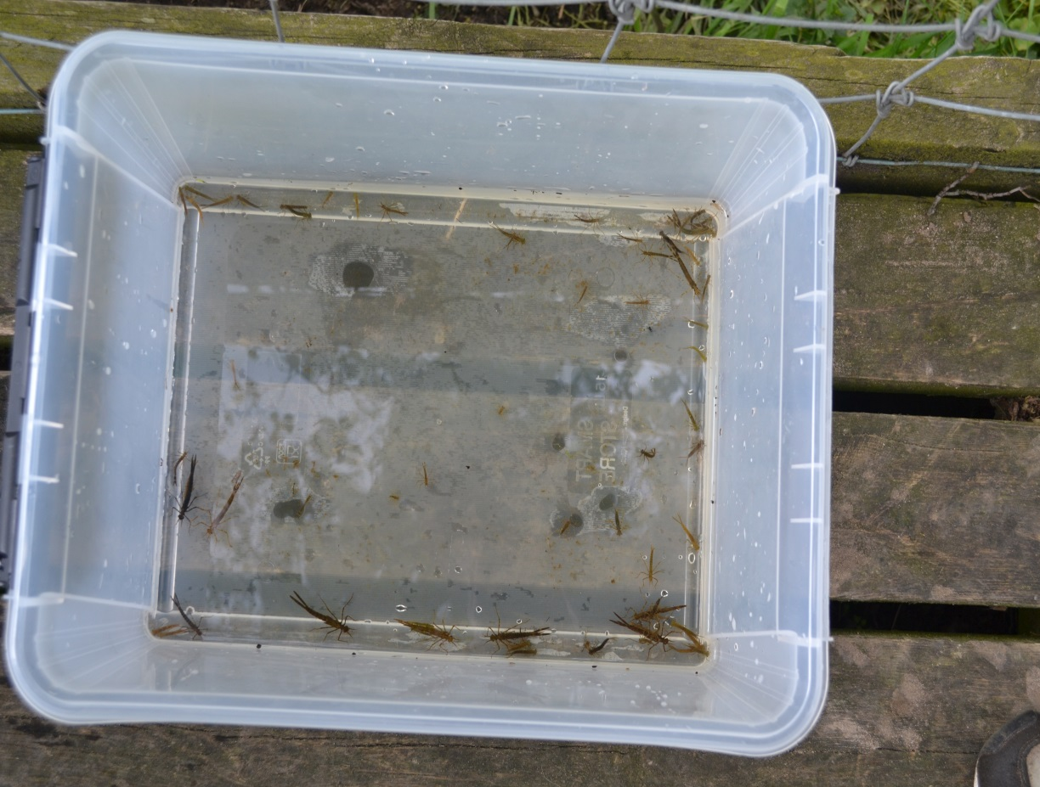

Fig 1. *Calopteryx splendens* larvae in Skåne. Here two generations are likely represented, as two distinct body-size groups can be observed.

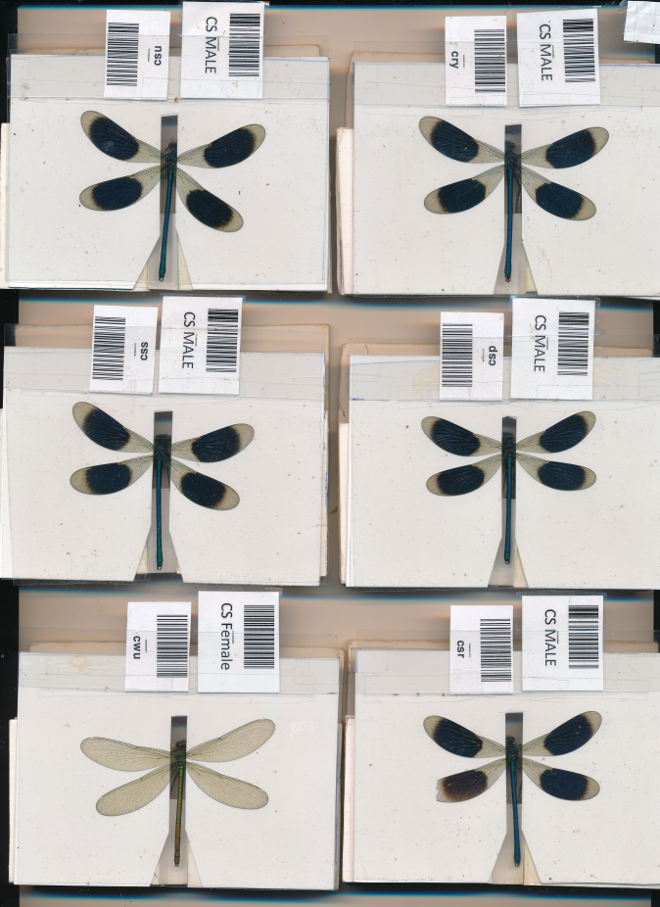

Fig 2. A scan of *Calopteryx splendens* males and females. Note that the female (upper left) has entirely transparent wings, unlike the males which have dark melanized wing patches, which function in sexual selection and species recognition. From images like these, I can obtain body size measurements and quantify individual variation in phenotypic traits such as wing length, body size, and the size and darkness of the melanized wing patches. These scans also allow us to process the large sample sizes usually needed to detect selection in the wild.

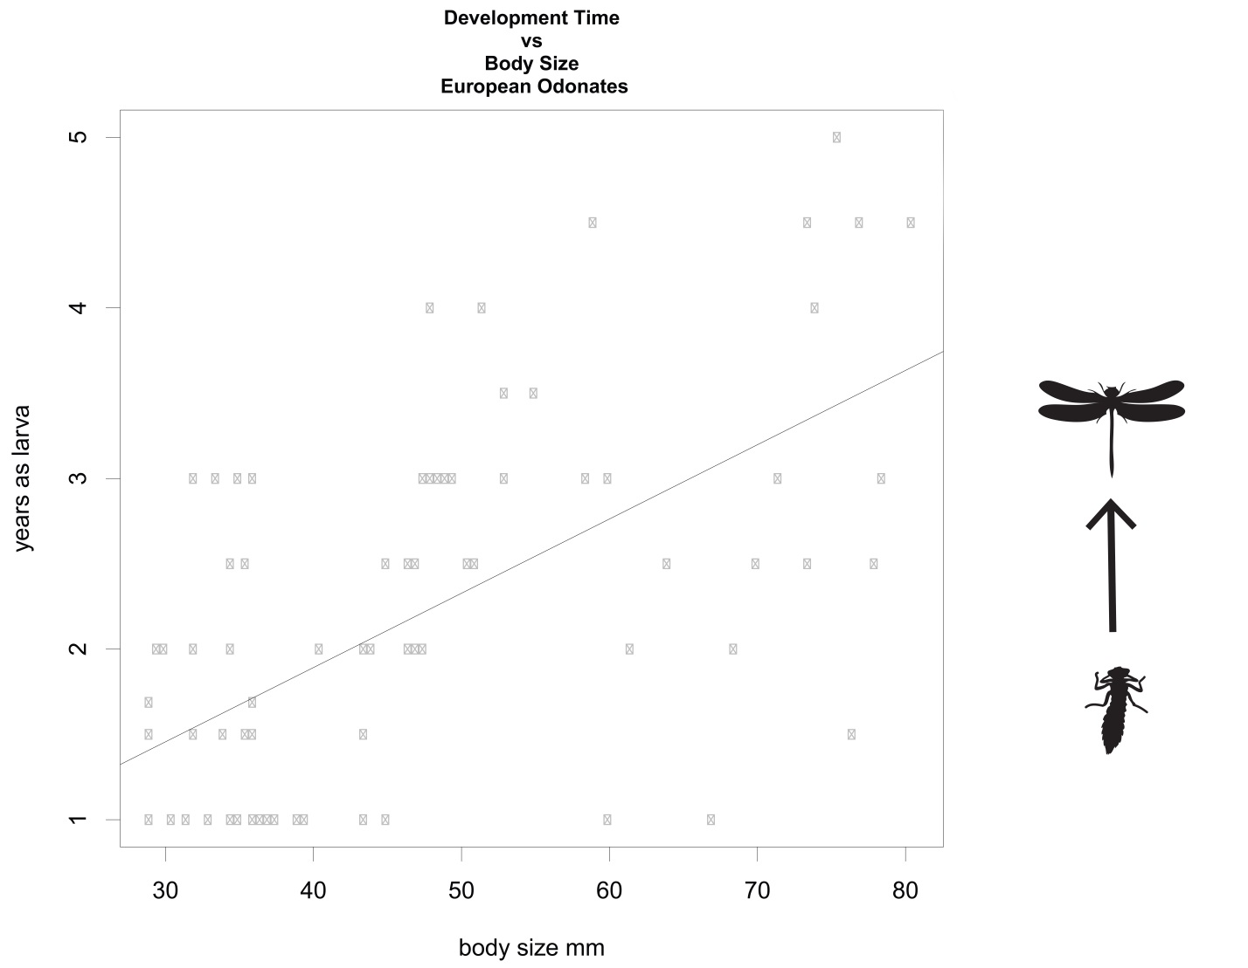

Fig 3. Adult body size compared to development time for European Odonate species. There is significant a positive relationship between time spent in the aquatic phase and adult size, even after controlling for phylogenetic non-independence.

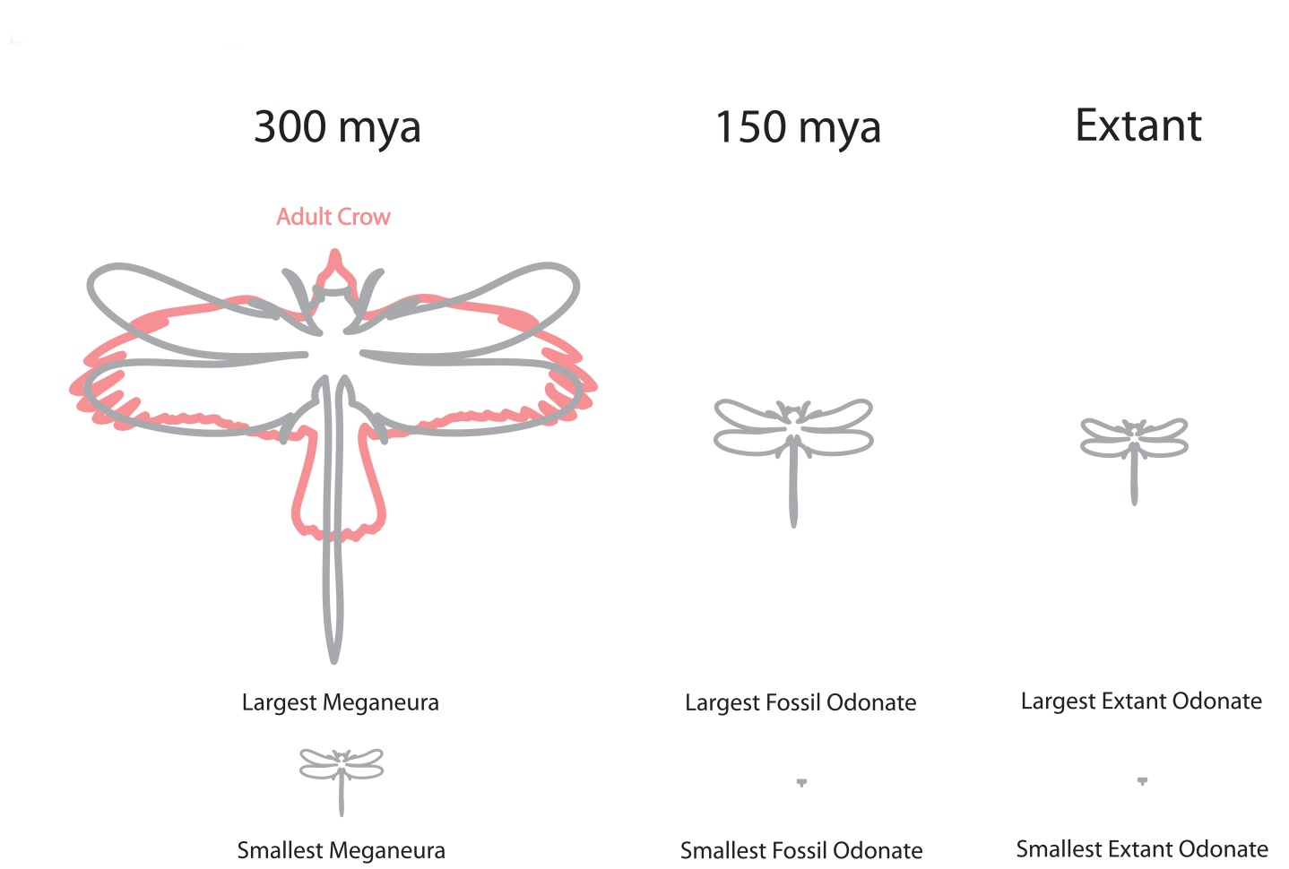

Fig 4. Size comparisons of fossils with extant taxa.

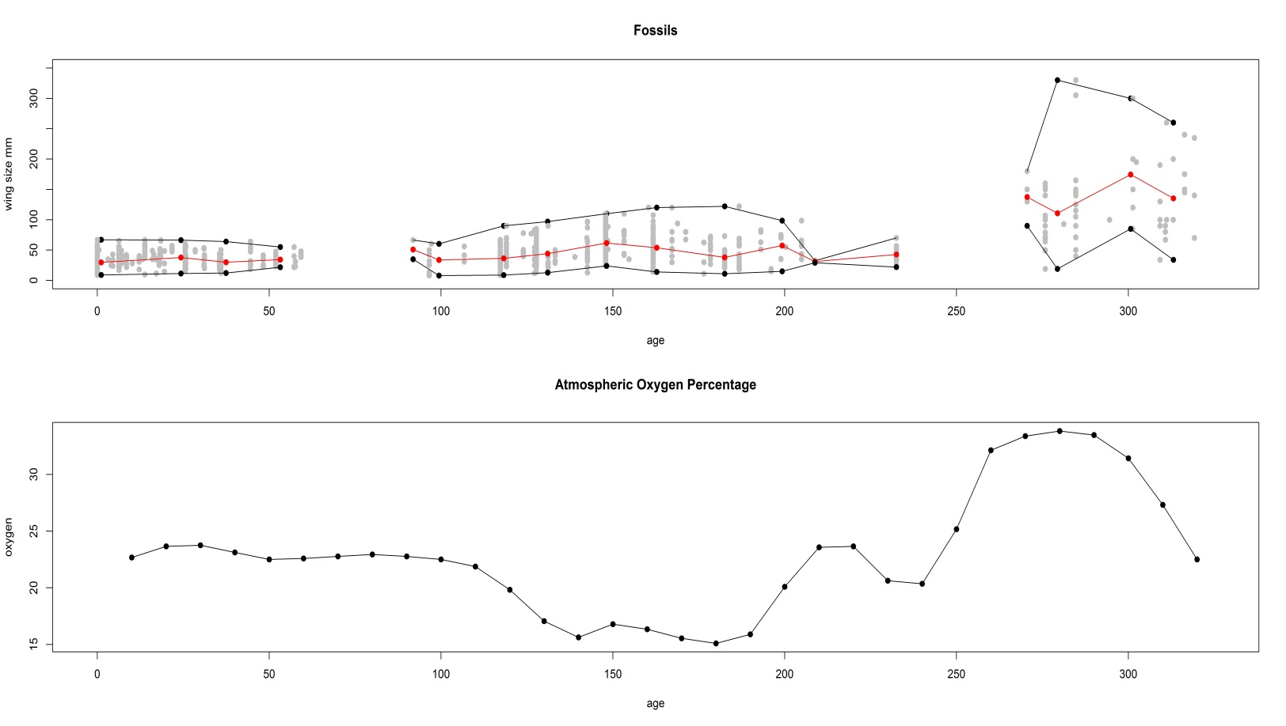

Fig 5. Oxygen level in the atmosphere over the last 350 million years (GEOCARBSULF model), the peak of which corresponds well to the peak seen in giant insects 300 mya (Clapham & Karr 2012). Body size (wing size) also appears to be decoupled from oxygen levels after that initial peak (Clapham & Karr 2012), although other oxygen-record reconstructions might show a different pattern (Harrison et al 2010).

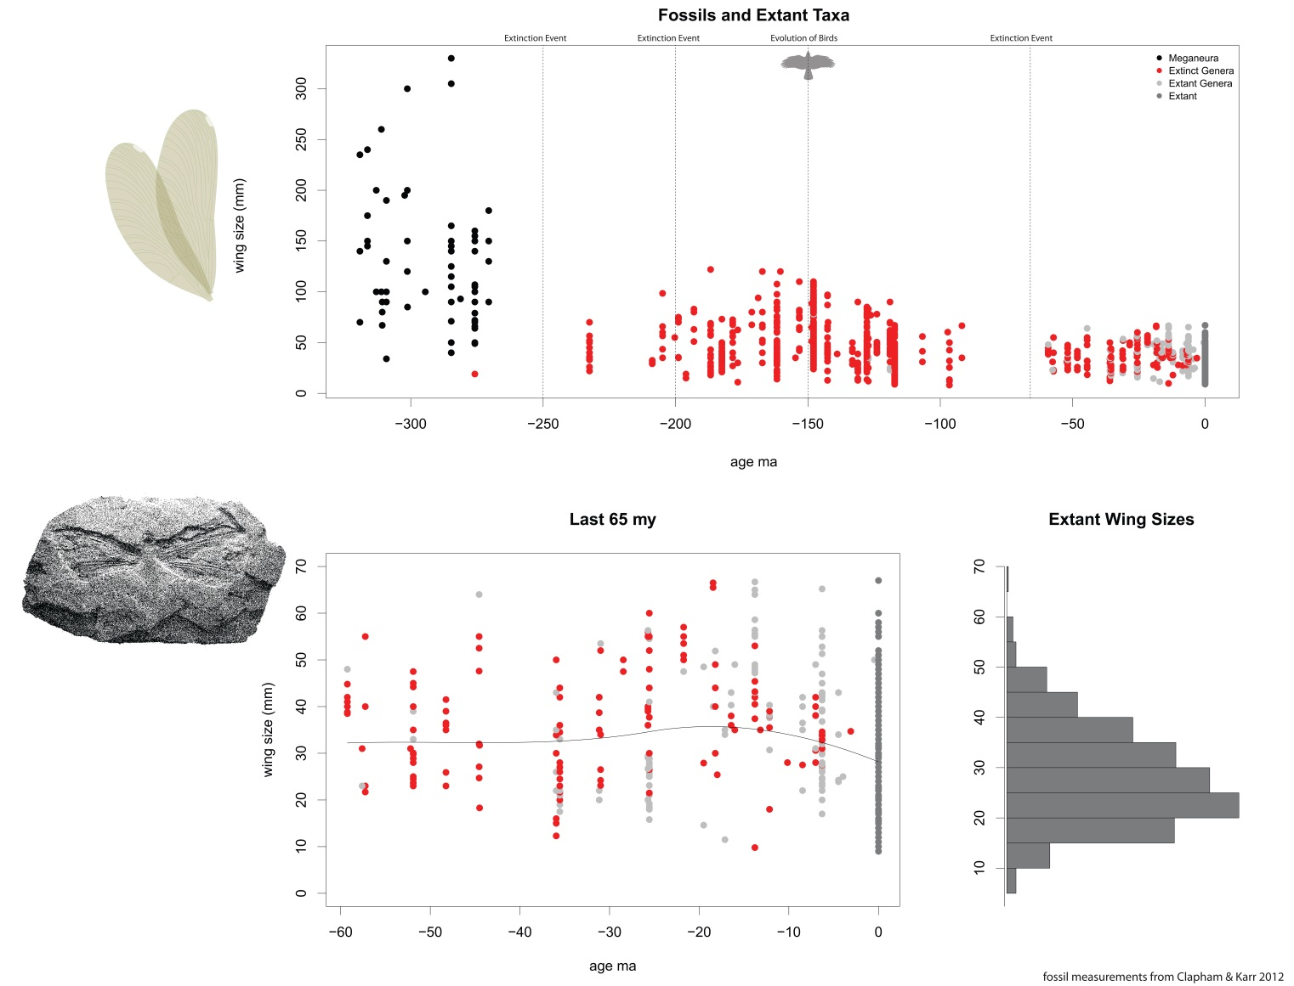

Fig 6. Wing size fossil data (a surrogate for body size) from the Paleobiology Database (paleobiodb.org)(Clapham & Karr 2012). Here we see (upper panel) that body size reached a maximum 300 mya and has fluctuated since then, due in part to several extinction events (dashed lines). In the last 65 my (lower panel), after the last major extinction event, body size has remain largely static. Mean size has not increased considerable, but the variance in body size seems to have increased over the last 65 my, likely following a constrained random walk process (Ornstein-Ulenbeck process).

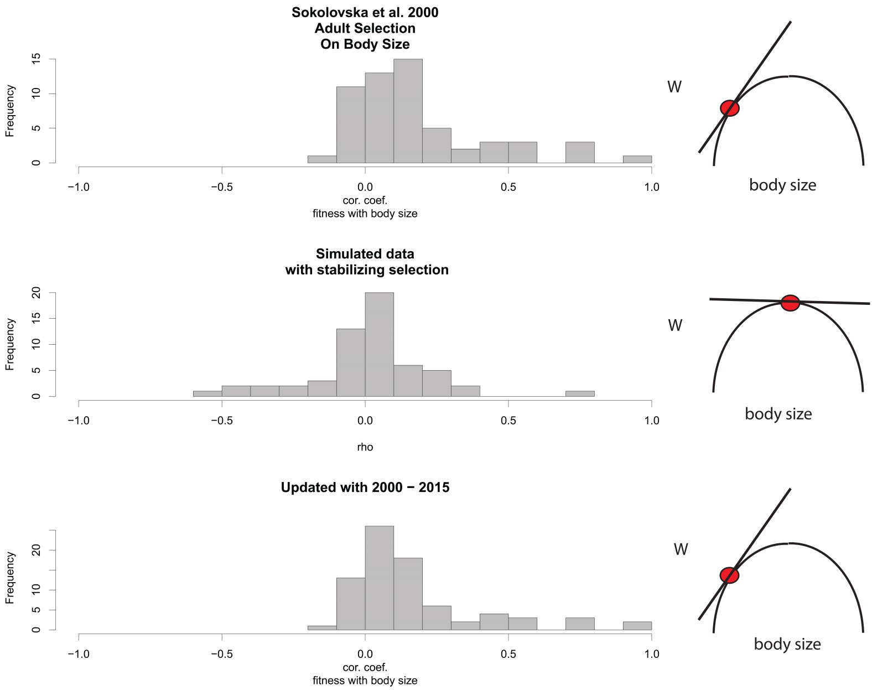

Fig 7. Despite the fossil record strongly indicating stasis, a meta-analysis was performed in 2000 showing that selection on body size in the adult stage (for both males and females) is largely positive (Fig #) (Sokolvska et al. 2000). Additionally, I have since updated the dataset with selection studies published between 2000-2015, and a similar pattern of largely positive correlation coefficients has been observed.

There has been some concern that a correlation coefficient is not an ideal measure of selection (Thompson & Fincke 2002), since it cannot capture effect size or any curvature of the fitness function. In the second panel, I show in simulations the symmetrical distribution of correlation coefficients one would expect if selection were largely stabilizing. Instead a positive-skewed distribution is seen in panels 1 and 2, indicating that there is an overall bias in selection in the adult stage for larger body size.

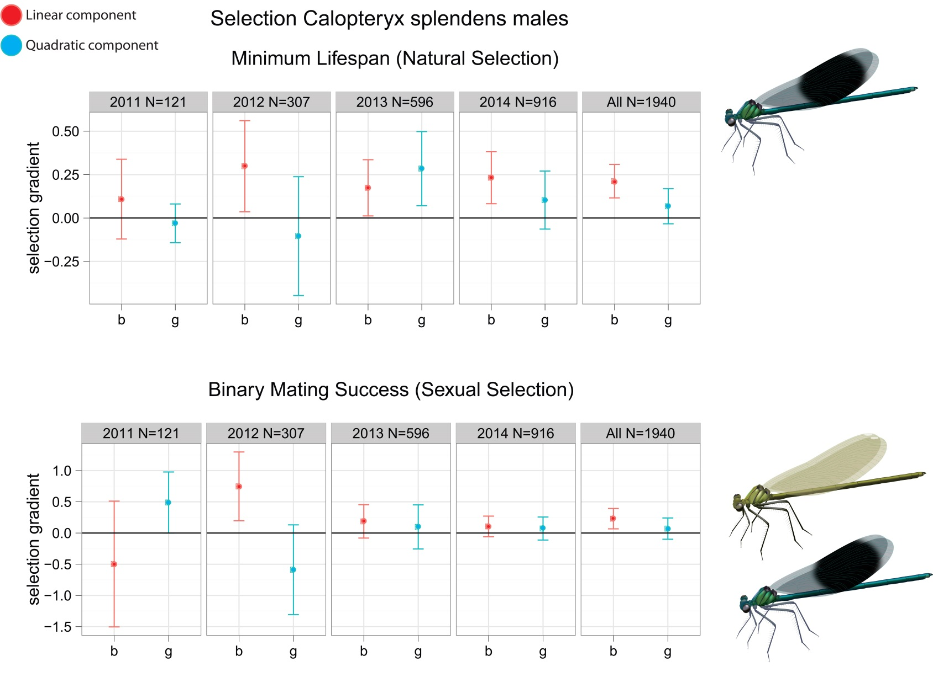

Fig 8. Selection gradients measured in the field on banded demoiselle (*Calopteryx splendens*) males from 2011 to 2014. Selection on body size has been largely positive for both mating success and minimum lifespan. Here **b** (red) denotes a linear selection gradients and **g** (blue) measures any curvature in the fitness function. A negative value of **g** would be interpreted as stabilizing selection on body size, whereas a positive value would indicate disruptive selection.

There is no evidence for stabilizing selection (the quadratic component shown in blue) in this population, even with large sample sizes. We interpret this as some unobserved selection pushing adults off of their adult optimum (most likely a tradeoff with development time).

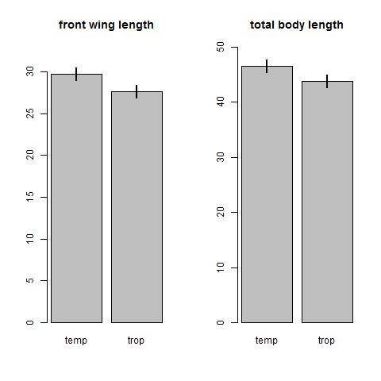

Fig 9. Odonates taxa are significantly smaller in the tropics (trop) than in temperate (temp) regions even after controlling for phylogenetic non-independence. This comparative result differs from what is seen at the intra-specific level, wherein body size usually decreases with latitude.

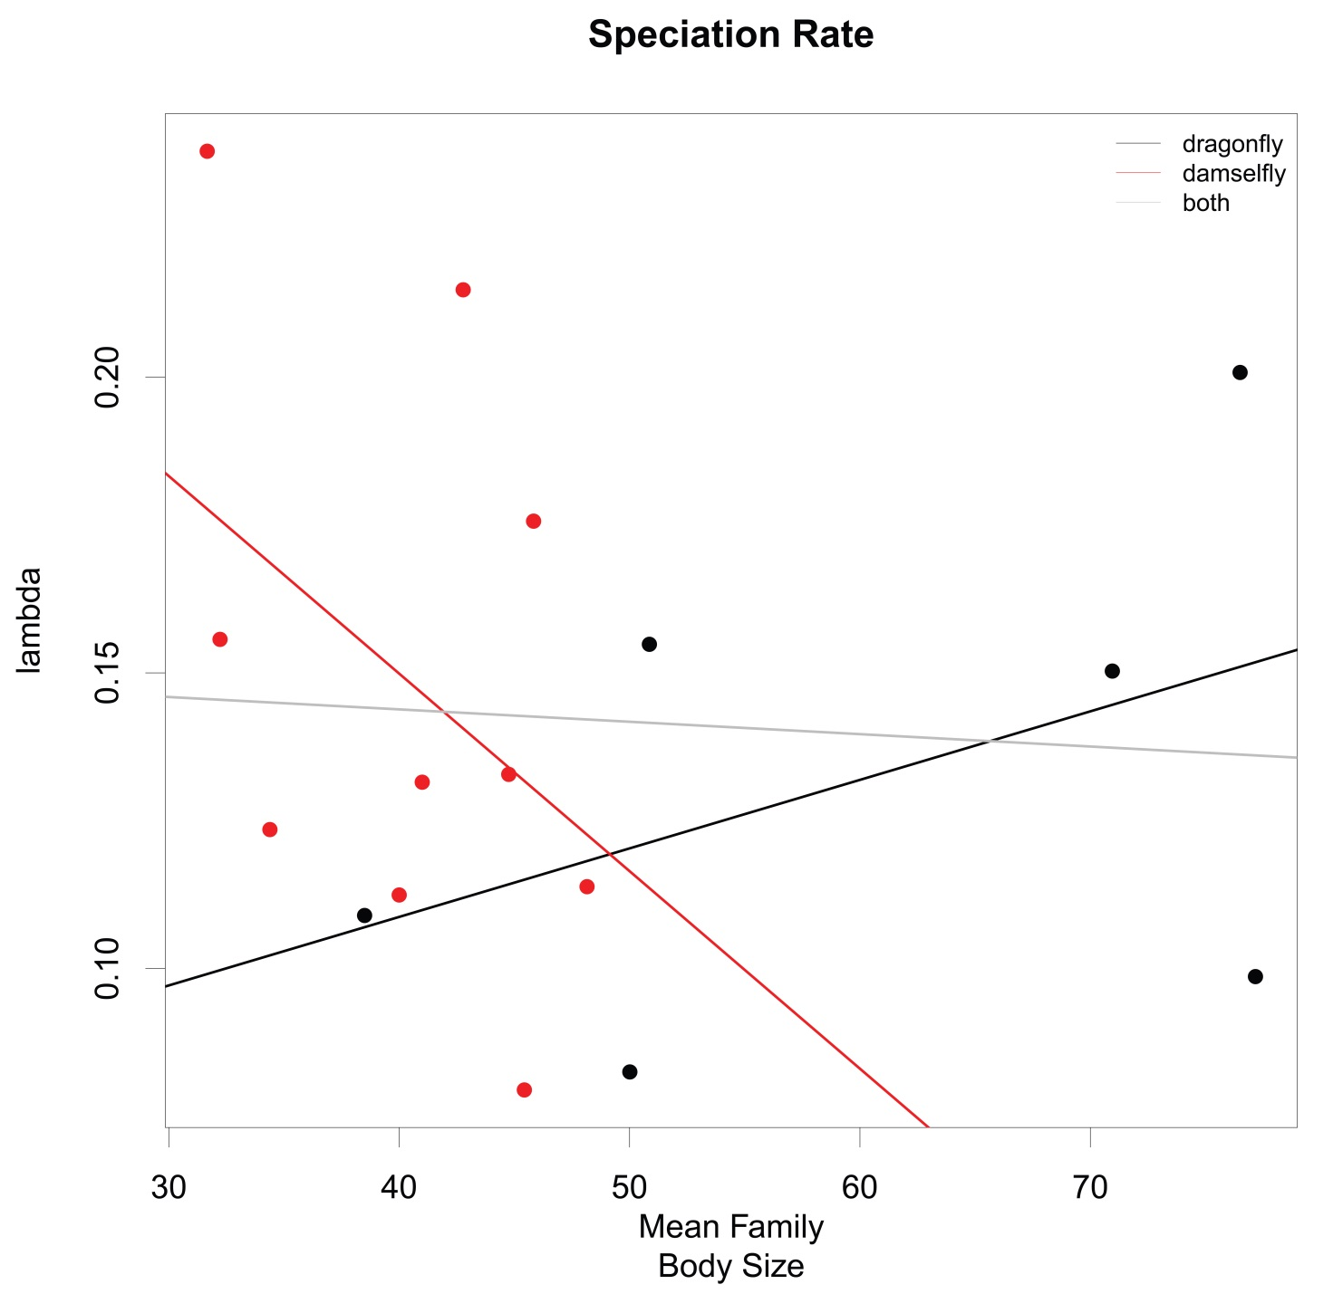

Fig 10. Speciation rate (lambda) (the number of species/unit time) was estimated for each family using the a pure birth model (i.e. extinction was ignored). Body size was taken as the mean body size of the family. Here we see a slight overall negative effect of body size on lambda when looking at dragonflies and damselflies together (gray). However, when comparing them separately dragonfly (black) body size had a positive effect on speciation rate, whereas damselflies (red) show the opposite relationship.

Additionally, a model with a second order term was also not significant, suggesting that body-size is not a particularly large determiner of speciation rate. This agrees with recent results in insects (Rainford et al 2016).

There was a some evidence, however, for an interaction between Suborder (damselfly or dragonfly) and body size (rate*Suborder = -0.0045, p = 0.147), indicating that speciation rate in damselflies and dragonflies have opposite reactions to body size. None of the slopes seen in this graph were significant, however, even before controlling for non-independence.

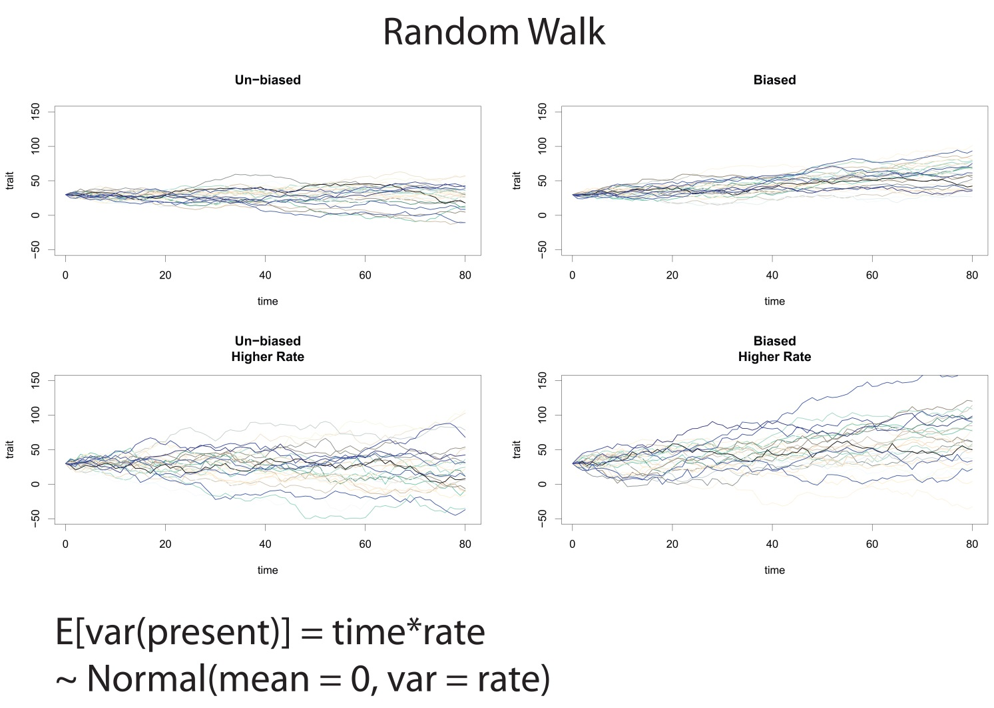

Fig 11. Simulated random walks illustrating different evolutionary scenarios. A random walk can be modeled as draws from a normal distribution at each time step, which are then added (or subtracted) from the previous time step. This process can be run several times, with each path taken representing a lineage drifting randomly though character space (different colors in the graph).

How quickly a trait evolves will depend on the rate of evolution, which is the variance of the normal distribution described above. The end result should produce a group of extant lineages spread with an expected value of the variance equal to the time*rate. It is only typically possible to estimate un-biased random walks from extant taxa data, and we must therefore rely on fossil data to show that the starting point is not biased.

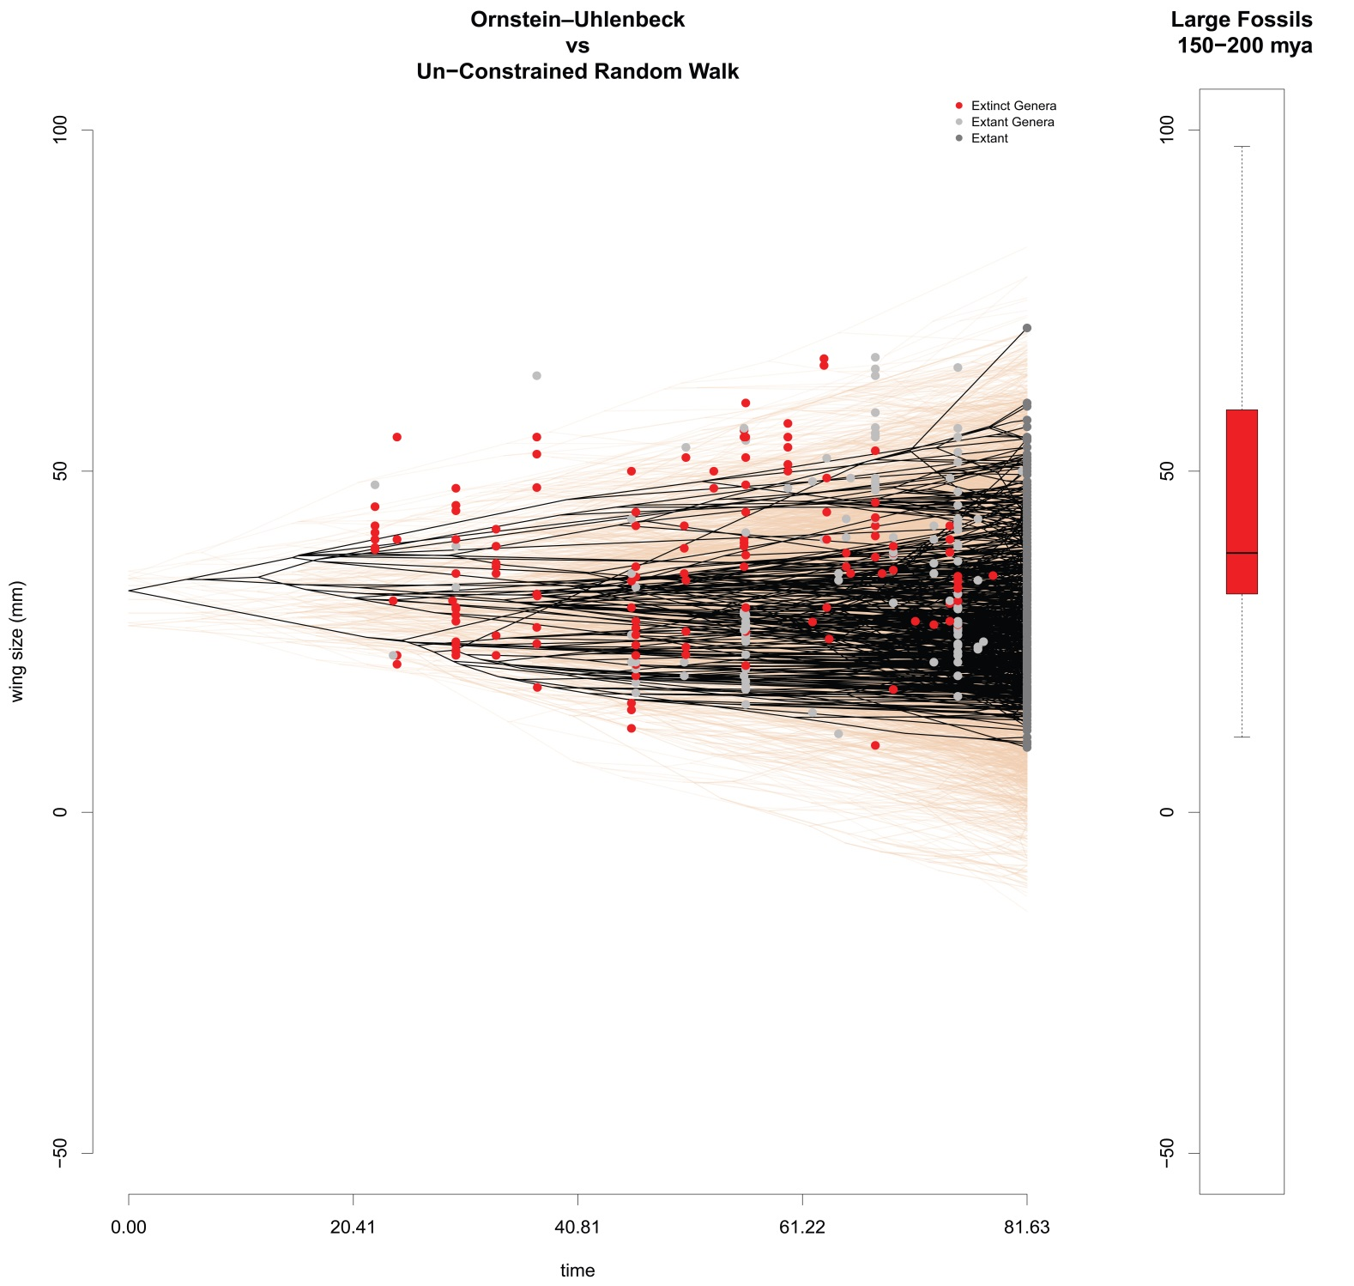

Fig 12. An Ornstein-Uhlenbeck (OU) model of body size (wing size) evolution. The black tree represents the observed data on body size from the extant taxa. The orange tree is data simulated without constraints with the estimated rate of evolution. The gray and red points represent fossils from extant and extinct genera, respectively. The red box plot to the right is the distribution of fossil body sizes from 150-200 mya, a period when body size in this lineage reached a local maximum.

Odonates in the modern age (the last 80 my since the last major extinction event), likely have not had enough time to reach the sizes observed in the fossil record 150 mya (or the maximum 300 mya), but nevertheless, with the current constraints (oxygen, birds, something else), they will likely remain small until the constraints on their body size are relaxed. In other words, there is evidence for stabilizing selection on body size that prevents an accumulation of interspecific body size variance that would be expected from a purely neutral evolutionary process (i.e. a Brownian Motion model) (BM: rate = 1.9, optim. = 32.4 mm, AIC = 5492; OU: rate = 2.3, alpha = 0.01, optim. = 31.8 mm, AIC = 5428).

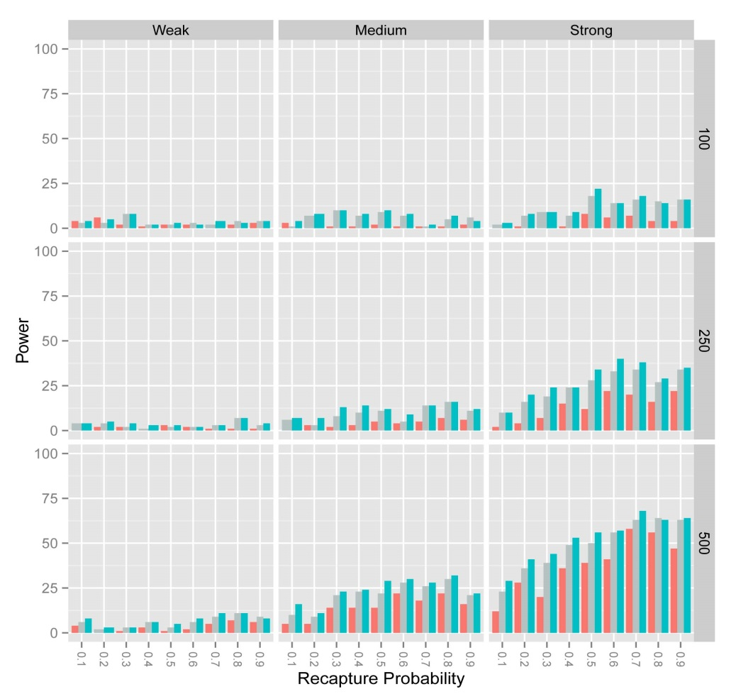

Fig 13. Power to detect stabilizing selection in the simulated dataset using three different methods: Lande-Arnold (LA; red), negative binomial (NB; gray), and mark-recapture (MR; blue). Each bar shows the percentage of times stabilizing selection was detected in our simulations under different conditions of recapture probability and selection strength. The right panel shows the sample sizes used (100, 250, 500 individuals). The upper panel shows the true underlying stabilizing selection gradient (γ: Weak = -0.06, Medium = -0.12, Strong = -0.18). The x-axes shows how we varied recapture probability from 0.1 (10% daily recapture probability) to 0.9 (nearly perfect detection). The y-axes show the percentage of runs when stabilizing selection was detected using the AIC-criterion (∆AIC > 2). Each bar represents 1000 runs. Linear selection values were set to 0 for all simulations in this figure, which is equivalent to assume that directional selection is absent and the population is sitting on its adaptive peak. For more details see the attached manuscript.



Fig 14. Our Odonate supertreee. Body size data is plotted on the tips as bars, and it is reconstructed in the branches of the tree, with cold colors (blue,gree) representing larger reconstructions and hot colors (red, yellow) denoting smaller sizes. Our tree contains around 1200 of 6000 taxa, but some taxa are not represented in this tree because of missing body size data. This tree is time calibrated with fossils.

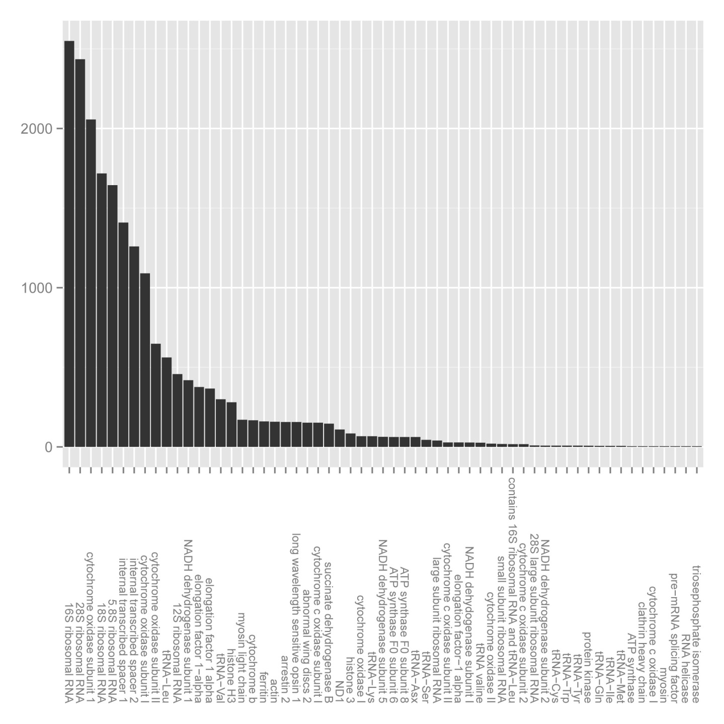

Fig 15. Genes downloaded from GeneBank to be used in the construction of our phylogenetic tree. Only a subset of genes downloaded were used in the tree construction process.

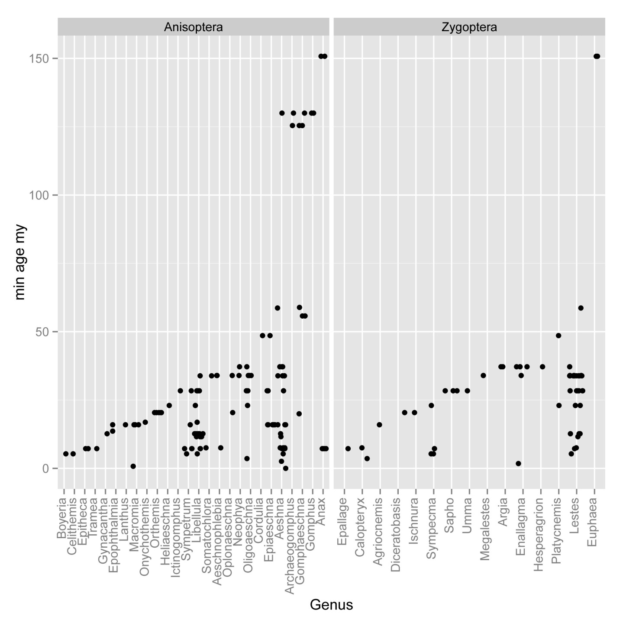

Fig 16. Fossils used to calibrated dating in our phylogenetic supertree.

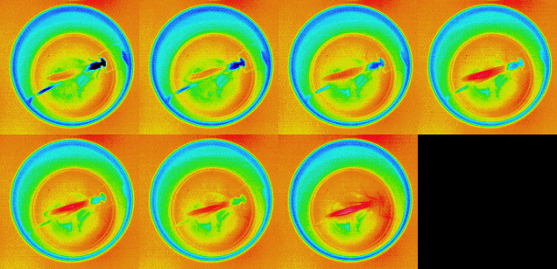

Fig 17. A series of thermal images of an individual damselfly through time. Here we see the damselfly slowly heating up from 5oC to ambient temperature. We predict that heating rate is an important physiological performance trait in ectotherms, which are dependent on ambient temperature to reach their optimal body temperature.

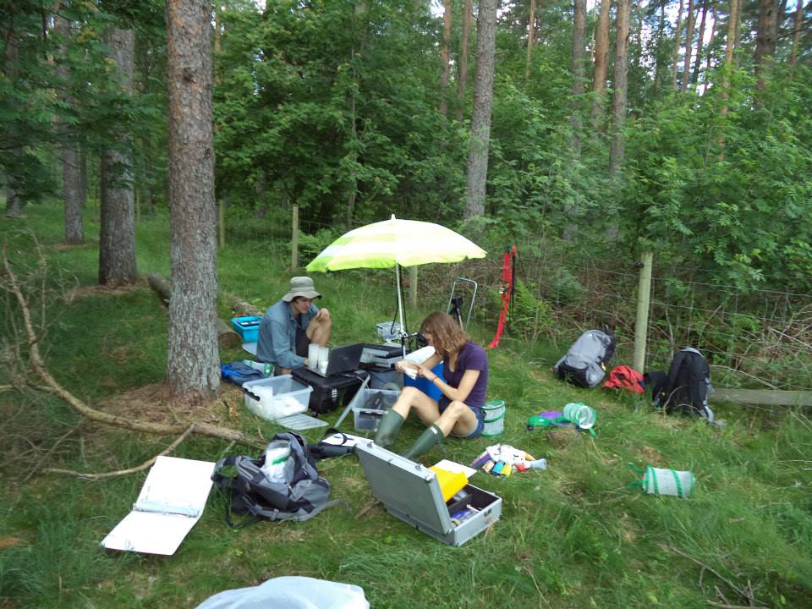

Fig 18. Field site in the southern part of the Swedish province Skåne, at Sövdemölla gård at Sövdesjön. Data was collected each summer (June and July) from for five years (2011, 2012, 2013, 2014, 2015).